SIMATS ENGINEERING

COURSE NAME: Compiler Design

COURSE CODE: CSA1406

EXPERIMENT 1
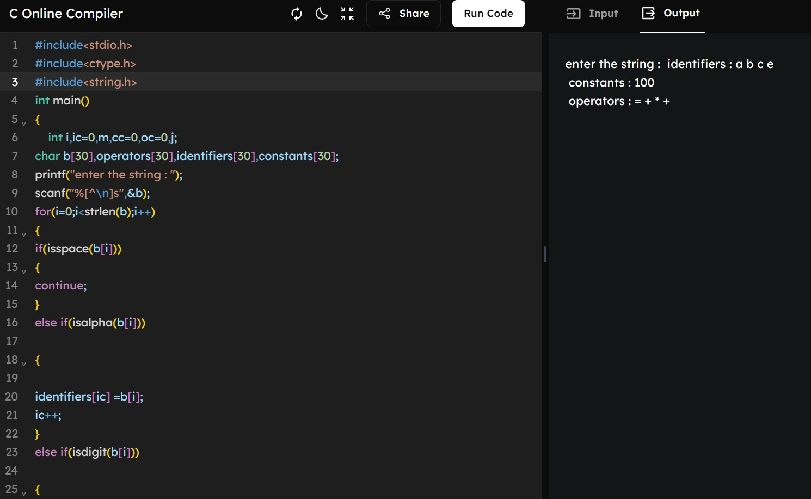

EXPERIMENT 2
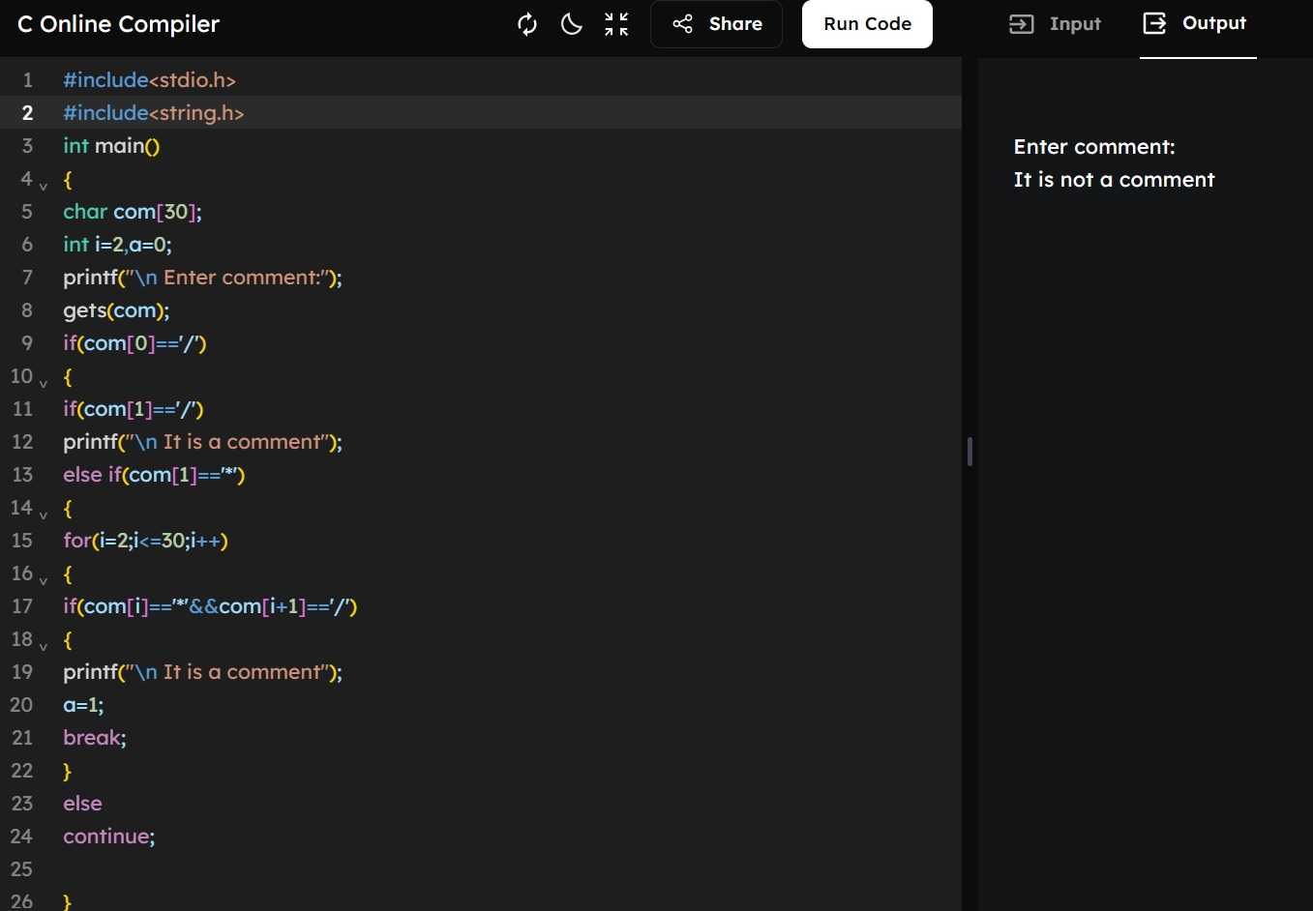

EXPERIMENT 3
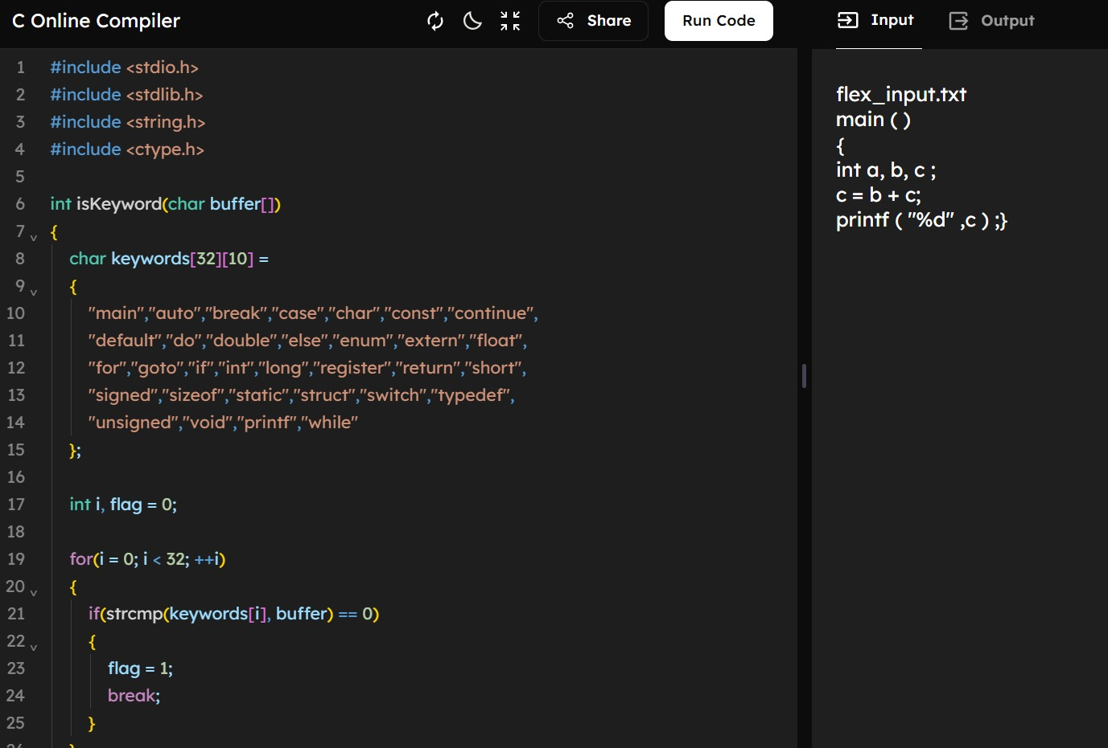

EXPERIMENT 4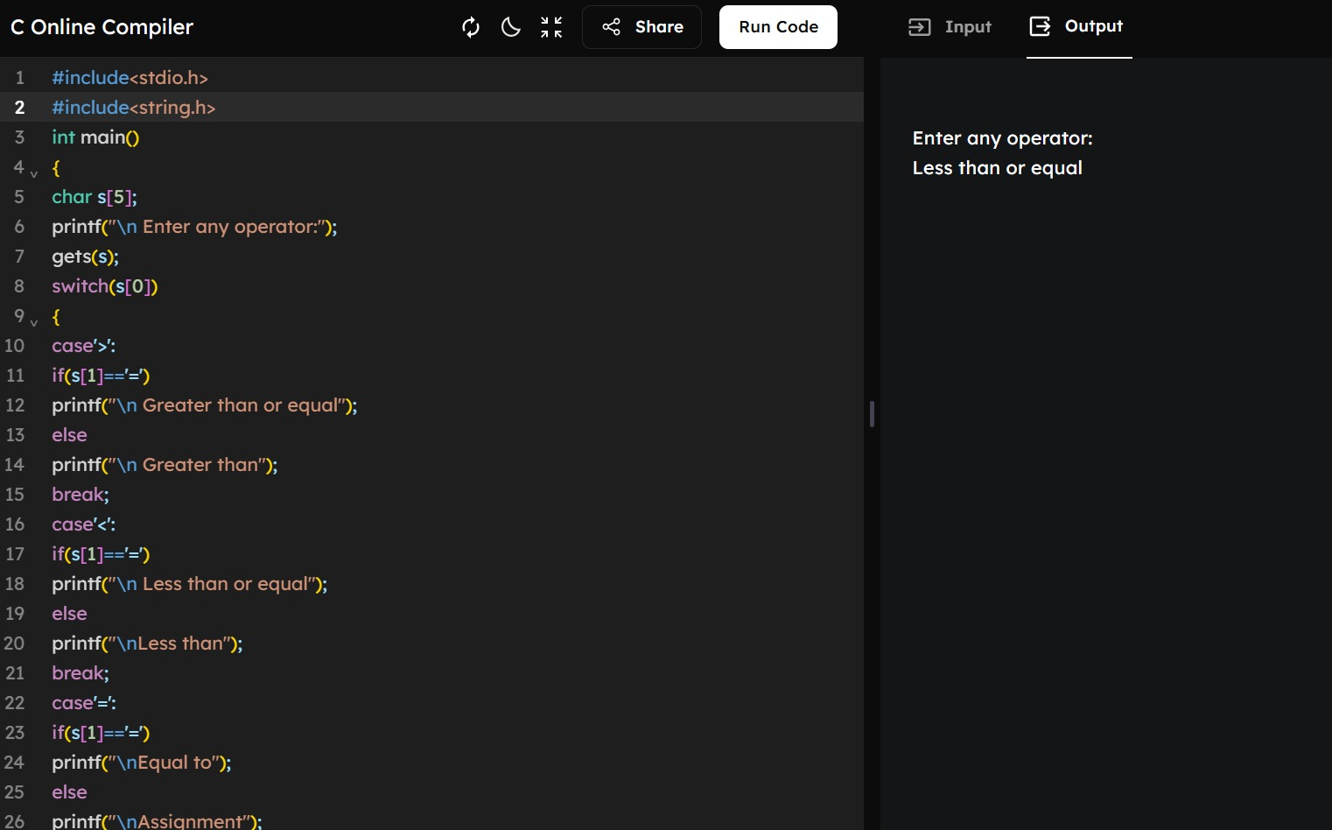

EXPERIMENT 5
